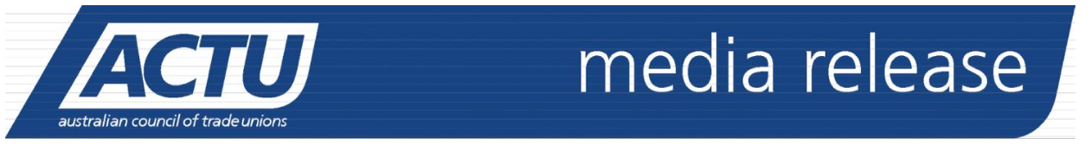

Wednesday 21 December
Turnbull Government must act now to protect public from Asbestos this Christmas
This Christmas, the Australian Council of Trade Unions is reminding the Federal Government of the importance of properly monitoring all imports to Australia, to ensure the public is not exposed to asbestos contaminated products.
Earlier this year, 307,000 crayons contaminated with asbestos were stopped at Australia’s border sparking serious concerns about what could have slipped through customs and come into contact with Australians.
The ACTU said it was deeply alarming that there was no way of knowing how many contaminated products made it into the hands of Australian children in childcare centres, schools and homes.
Asbestos claims the lives of more than 500 Australians each year and the ACTU said the Federal Government needed to better resource the Australian Border Force so that it could properly monitor all imports and protect people from the dangerous material.
Quotes attributable to Michael Borowick, Assistant Secretary, ACTU:
“It’s terrifying to think that Christmas presents such as crayons, given to children could be contaminated with traces of asbestos. We need to be sure that all imports to Australia are properly screened so that nothing harmful can slip through the cracks and into the hands of Australians.
“The Federal Government needs to be do more to ensure that there is an effective mechanism in place to enforce the ban on asbestos and no company can get away with importing this dangerous material.
“Asbestos is a deadly product – the Turnbull Government needs to do everything it can to address the current failings in regulation and enforcement of the import ban.
“Current enforcement is simply not good enough. This Christmas we need to be sure that there are effective measures in place to prevent anyone else coming into contact with asbestos contaminated products.”
ENDS
Media contact: Peter Green 0400 764 200 or ACTU Media 03 9664 7315

